LAB EXAMINATION – 2 (COMPUTER NETWORKS)
SRIDHAR C(RA2211026050120)

Objective:
Set up and configure a network topology using RIP and OSPF routing protocols in Cisco Packet Tracer. Customize the network by assigning each computer a name and an IP address using the last three digits of the roll number.
Procedure:
- Network Topology Design:
  - Create a topology that includes:
    - 10-12 computers distributed across two LANs.
    - Use two switches, each connecting a group of computers in a separate LAN.
    - Two routers connected via a WAN link.
  - Device Distribution:
    - LAN 1: 5-6 computers connected to Switch 1.
    - LAN 2: 5-6 computers connected to Switch 2.
  - Device Naming Convention:
    - Each computer was assigned a name in the format: PC_Roll Number (e.g., PC_123).
- IP Address Configuration:
  - Assign IP addresses to the computers in each LAN.
    - LAN 1: IP addresses configured with the subnet 192.168.1.0/24, where each PC's IP address ends with the last three digits of the roll number (e.g., 192.168.1.123 for PC_123).
    - LAN 2: IP addresses configured with the subnet 192.168.2.0/24, similarly using the roll number for the last octet (e.g., 192.168.2.123 for PC_123).
  - Router Interface Configuration:
    - Router 1 interfaces were set up with the IP address 192.168.1.1/24 for LAN 1.
    - Router 2 interfaces were configured with 192.168.2.1/24 for LAN 2.
    - The WAN link between routers used a point-to-point subnet (e.g., 10.0.0.1/30 for Router 1 and 10.0.0.2/30 for Router 2).
- Routing Protocols Configuration:
  - Configure RIP v1 on Router 1:
    - Added the network commands for 192.168.1.0 and 10.0.0.0 to enable RIP routing.
  - Configure OSPF on Router 2:
    - OSPF was set up using the area 0 configuration.
    - Added network commands for 192.168.2.0 and 10.0.0.0.
  - Ensuring Communication:
    - Verified that the routes were properly advertised and shared between the two routing protocols using route redistribution.
- Packet Tracer Configuration Steps:
  - Add Devices and Create Connections:
    - Placed all computers, switches, and routers in the workspace.
    - Connected devices with appropriate cabling (copper straight-through for computers to switches and serial connections for routers).
  - Configure IP Addresses:
    - Manually set IP addresses for all computers and configured default gateways.
  - Set Up Routing:
    - Enabled RIP on Router 1 and OSPF on Router 2.
    - Configured route redistribution on both routers for seamless communication.
  - Verification:
    - Used the ping command to test connectivity between LAN 1 and LAN 2.
    - Verified route tables on both routers to ensure correct route advertisement.
- Simulation:
  - Cisco Packet Tracer Simulation Mode:
    - Switched to simulation mode to observe packet transmission.
    - Initiated message sending from a computer in LAN 1 to a computer in LAN 2.
    - Verified the successful transmission of the message and inspected routing paths.
- Documentation and Submission:
  - Procedure Documentation: Step-by-step process of network configuration was documented as described above.
  - Screenshots: Added all relevant screenshots, covering network design, IP configurations, and successful message transmission.
  - Packet Tracer File: Saved the .pkt file with the completed configuration.
  - GitHub Submission: Uploaded all documents, screenshots, and the .pkt file to a GitHub repository named "Lab 2 Exam".
  - Repository Submission: Submitted the GitHub repository link to the instructor.

Output Screenshots:
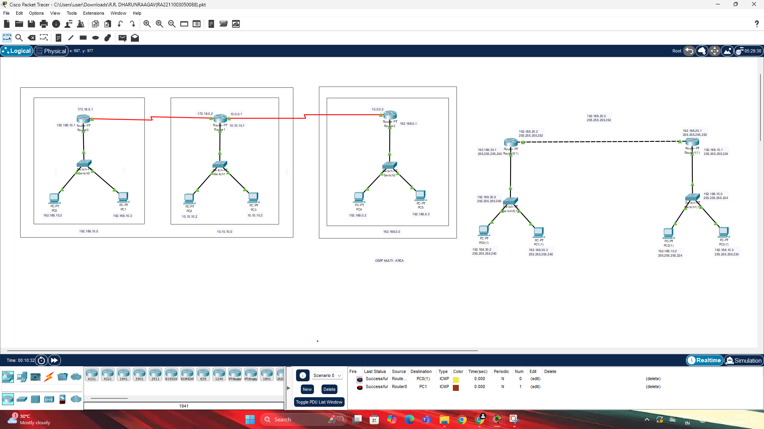

Results:
- Successfully configured a network topology with two LANs using RIP and OSPF routing protocols.
- All devices were assigned IP addresses based on the last three digits of the roll number, maintaining the required subnet structure.
- Routing protocols were configured on the routers, allowing seamless communication between LAN 1 and LAN 2.
- The simulation mode in Cisco Packet Tracer demonstrated successful packet transmission across the network.
- Documentation and files were submitted as per the requirements.

Name: SRIDHAR C
Class: CSE AIML-B
Reg.No: RA2211026050120

